USE CASE DIAGRAM: TASK MANAGEMENT SYSTEM.

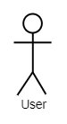

<<extend>>

<<extend>>

<<extend>>

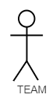

<<extend>>

<<extend>>

Click terminate process if all tasks and project are complete

<<include>>